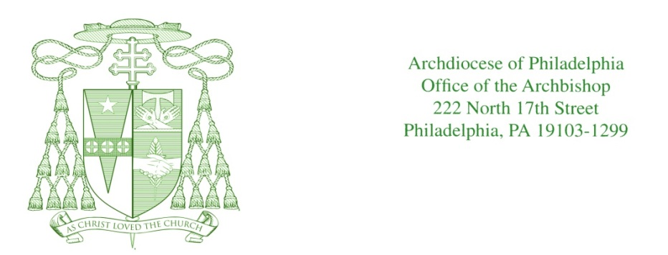

June 4-5, 2016

Dear friends,

A bill is currently pending in our state senate, HB 1947, that poses serious dangers for all of our local parishes and for the ministries, charities and schools of our archdiocesan Church. With this letter, I urge you to write or telephone your local state senator and members of the state Senate Judiciary Committee to vote against HB 1947, and especially to oppose any retroactivity provision in the civil statute of limitation covering sexual abuse.

All of us are rightly angered by the crime of sexual abuse. Over the past decade the Church has worked very hard to support survivors in their healing, to protect our children and to root this crime out of Church life. But HB 1947 and bills like it are destructive legislation being advanced as a good solution. The problem with HB 1947 is its prejudicial content. It covers both public and religious institutions -- but in drastically different and unjust ways. The bill fails to support all survivors of abuse equally, and it’s a clear attack on the Church, her parishes and her people.

HB 1947 is retroactive for private and religious entities, but not retroactive for public institutions. It places very low caps on damages for sexual abuse in public schools in the future. And it makes it hard for abuse victims to sue public institutions going forward. Meanwhile, private and religious entities face unlimited liability for exactly the same evil actions, and not just going forward, but also in the past. This is not justice. In fact, HB 1947 actually excludes most victims. And it also targets innocent Catholic parishes and families, like your own, who will bear the financial burden of crimes committed by bad individuals in the past, along with the heavy penalties that always result from these bad bills. This is not just an archdiocesan problem. In other states where similar legislation passed, local parishes have been sued, resulting in parish and school closures and charity work being crippled. The effect of bills like HB 1947 is to erase the sacrifices of generations of faithful Catholics who have done nothing wrong.

The Church in Pennsylvania accepts its responsibility for the survivors of clergy sex abuse. It’s committed to helping them heal for however long that takes. But HB 1947 and bills like it are not an answer. This kind of legislation is unjust and deeply misleading. It benefits too few victims, and it ends up punishing Catholic parishes and families who are innocent of any wrongdoing.

This is a serious and time-sensitive matter. Please take a few minutes to review the important information materials available at the exits after Mass. Senate hearings begin on or around June 13. Please act now to contact your senator, and members of the Senate Judiciary Committee, and urge them to oppose HB 1947 and any effort to impose civil statute retroactivity. You can do that quickly and easily by visiting www.pacatholic.org. That’s the website for our state Catholic Conference, and you’ll see a prominent link on the homepage about this vital matter. Thank you and God bless you.

Sincerely yours in Jesus Christ,

Most Reverend Charles J. Chaput, O.F.M. Cap.
Archbishop of Philadelphia

