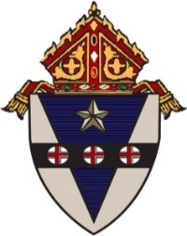

April 8, 2022
Dear Friends in Catholic Education,
A decade ago, the Archdiocese of Philadelphia entered into a unique partnership with Faith in the Future under an agreement which is set to expire on June 30. It was created at a time when the Archdiocesan system of high schools faced many challenges threatening their viability.
As part of a highly integrated and multi-faceted response, Faith in the Future designed and executed an overarching strategic vision to bolster the system as a whole while addressing the unique needs of each school.
Since its inception, Faith in the Future has worked tirelessly alongside senior administrators in the Office of Catholic Education and local school leaders. It produced a targeted plan for specific investments to provide for an outstanding Catholic education for current and future students.
Thanks to that hard work, as well as the generosity of numerous foundations and private benefactors, significant improvements were made. Over the past ten years, Faith in the Future has enhanced academic excellence; integrated technology components throughout the instructional model; delivered financial sustainability; increased affordability for families; stabilized enrollment in the system; and demonstrated a commitment to the Catholic identity at the core of Archdiocesan schools.
During the recent COVID-19 pandemic, the longstanding focus on state-of-the-art instructional technology improvements paid great dividends. Combined with Faith in the Future’s ongoing emphasis on fostering strong leadership and professional development, it enabled the secondary schools to provide seamless instruction to all students in person and virtually.
Given those accomplishments, and with the conclusion of the agreement between the Archdiocese and Faith in the Future approaching, now is an appropriate time to embrace a new operational management structure. It will be centralized within the Archdiocese, which has always owned the schools. The Archdiocese and Faith in the Future are committed to implementing this new management plan and prepared to do so without disruption to the school system.
After June 30, operational management of the high schools will fall under the administrative purview of the auxiliary bishop designated as responsible for the oversight of Catholic education in the Archdiocese of Philadelphia. The Chief Operating Officer for Secondary Education (COO) will report directly to this individual. The COO will provide supervisory oversight for high school presidents and work in collaboration with the local boards of each high school. The COO will also supervise the work of the Superintendent for Secondary Schools. The Superintendent will have administrative jurisdiction over the high school principals in collaboration with the high school presidents. The Superintendent will also supervise key staff within the Office of Catholic Education responsible for supporting the high schools.
Faith in the Future and its Board now have the opportunity to explore its plans and mission moving forward. The Archdiocese of Philadelphia is appreciative of Faith in the Future’s significant contributions and is open to conversations on this topic.
Both Faith in the Future and the Archdiocese recognize that the many advancements and successes of the past ten years would not have been possible without the support of various foundations and individual donors who made contributions to Faith in the Future for a variety of worthy purposes. We take this opportunity to express our deep gratitude for their generosity and commitment to our young people. We understand that the majority of those gifts were made for specific purposes with donor restrictions. Those restrictions will be respected and the donated funds expended consistent with their express purpose.
Our shared top priority is to provide an exceptional Catholic education for the students and families served by the Archdiocesan high school system. Our schools exist to educate and form young men and women of character who graduate poised to lead through service to others with the heart of a missionary disciple. We are grateful for the trust placed in us by school families throughout the region and pledge to do our utmost for their benefit.
Sincerely,
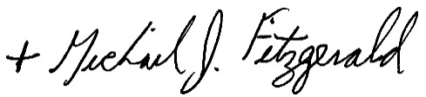 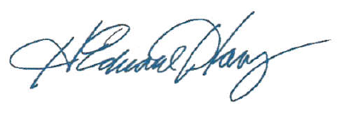
Most Reverend Michael J. Fitzgerald Mr. H. Edward Hanway
Auxiliary Bishop of Philadelphia Chair, Board of Faith in the Future

